Oyster Bay experienced an average daily temperature of 12.85 +/- 4.16 C. Minimum observed temperature was 2.517 C, Maximum observed temperature was 31.88 C. The coefficient of variation (CV) was 0.3233341.

Fidalgo experienced an average daily temperature of 10.87 +/- 3.13 C. Minimum observed temperature was 3.05 C, maximum observed temperature was 24.06 C. The CV was 0.3049562.

Manchester experienced an average daily temperature of 11.33 +/- 2.21 C. Minimum observed temperature was 5.45 C, maximum observed temperature was 18.05 C. The CV was 0.1947315.

Dabob experienced an average daily temperature of 10.64 +/- 3.69 C. Minimum observed temperature was -3.32 C, maximum observed temperature was 27.67 C. The CV was 0.3470937.

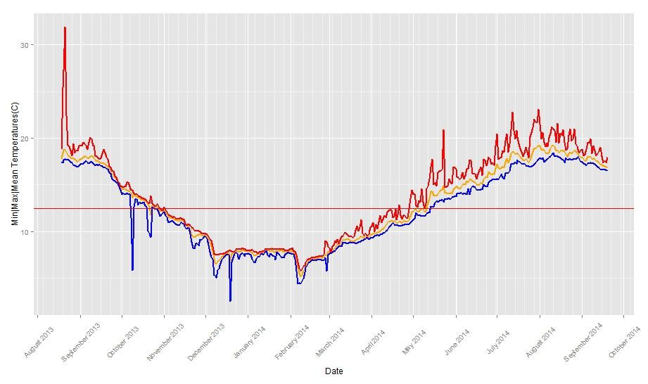
Figure 1. Oyster Bay Temperature Data in Celsius (August 2013 to September 2014) Blue line is minimum daily temperature, red line is maximum daily temperature, orange line is median daily temperature, red horizontal line is 12.5C spawning threshold.

Month | Mean Temperature | Std. Dev. | Maximum (Obs) | Minimum (Obs)
2013-08 | 18.02976 | +/-1.101268 | 31.88 | 16.903
2013-09 | 17.06694 | +/-1.04821 | 20.043 | 14.421
2013-10 | 13.34995 | +/-0.918077 | 15.282 | 5.86
2013-11 | 10.67302 | +/-0.91295 | 12.594 | 8.182
2013-12 | 7.770806 | +/-0.812125 | 9.768 | 2.517
2014-01 | 7.810293 | +/-0.209897 | 8.182 | 6.674
2014-02 | 6.898092 | +/-0.776371 | 8.978 | 4.415
2014-03 | 8.9183 | +/-0.568242 | 11.236 | 7.682
2014-04 | 10.73237 | +/-0.695753 | 14.421 | 9.275
2014-05 | 13.47825 | +/-1.113377 | 20.901 | 11.236
2014-06 | 15.51379 | +/-0.74385 | 19.187 | 13.75
2014-07 | 17.88636 | +/-0.971264 | 23.1 | 15.569
2014-08 | 18.49966 | +/-0.566504 | 21.569 | 17.379
2014-09 | 17.5186 | +/-0.515754 | 19.948 | 16.523
Table 1. Monthly Temperature Statistics for Oyster Bay.

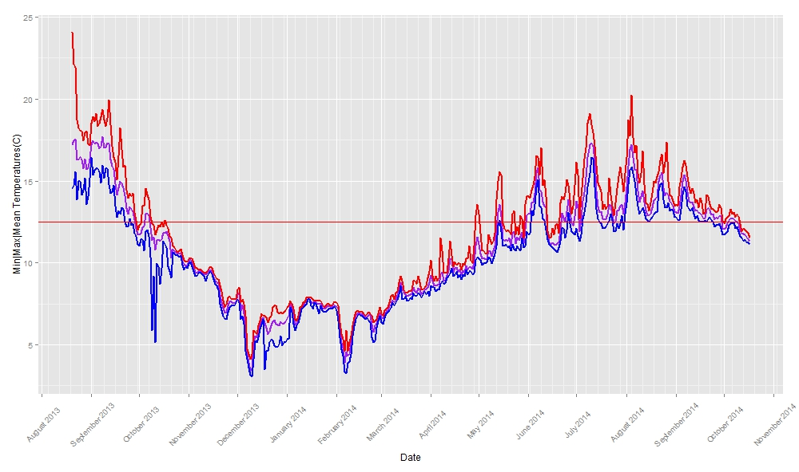
Figure 2. Fidalgo BayTemperature Data in Celsius (August 2013 to October 2014) Blue line is minimum daily temperature, red line is maximum daily temperature, purple line is median daily temperature, red horizontal line is 12.5C spawning threshold.

Month | Mean Temperature | Std. Dev. | Maximum (Obs) | Minimum (Obs)
2013-08 | 16.34317 | +/-1.240026 | 24.062 | 13.558
2013-09 | 15.31694 | +/-2.011672 | 19.948 | 11.139
2013-10 | 11.31524 | +/-1.048088 | 14.517 | 5.141
2013-11 | 8.720549 | +/-1.015041 | 10.259 | 6.573
2013-12 | 6.037887 | +/-1.173657 | 8.481 | 3.049
2014-01 | 7.24692 | +/-0.478899 | 7.882 | 5.347
2014-02 | 6.114322 | +/-1.000087 | 7.582 | 3.261
2014-03 | 7.943623 | +/-0.610812 | 9.472 | 6.268
2014-04 | 9.514967 | +/-0.745366 | 13.558 | 8.282
2014-05 | 11.40334 | +/-0.979874 | 15.569 | 9.866
2014-06 | 12.85314 | +/-1.324983 | 16.999 | 10.651
2014-07 | 13.84214 | +/-1.588132 | 19.092 | 11.334
2014-08 | 14.4142 | +/-1.272037 | 20.234 | 12.497
2014-09 | 13.3386 | +/-0.807058 | 16.237 | 11.722
2014-10 | 12.14833 | +/-0.474714 | 13.269 | 11.139
Table 2. Monthly Temperature Statistics for Fidalgo Bay.
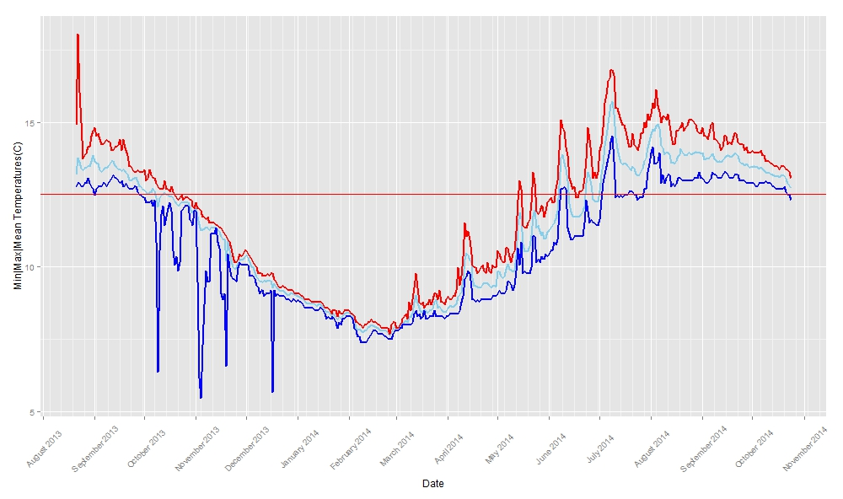
Figure 3. Manchester Temperature Data in Celsius (August 2013 to October 2014) Blue line is minimum daily temperature, red line is maximum daily temperature, light blue line is median daily temperature, red horizontal line is 12.5C spawning threshold.

Month | Mean Temperature | Std. Dev. | Maximum (Obs) | Minimum (Obs)
2013-08 | 13.53608 | +/-0.608937 | 18.045 | 12.69
2013-09 | 13.28304 | +/-0.465928 | 14.804 | 12.401
2013-10 | 12.33953 | +/-0.401881 | 13.365 | 6.37
2013-11 | 10.89575 | +/-0.799238 | 12.207 | 5.45
2013-12 | 9.450245 | +/-0.43898 | 10.553 | 5.655
2014-01 | 8.561135 | +/-0.247711 | 9.077 | 7.882
2014-02 | 7.892871 | +/-0.218211 | 8.481 | 7.381
2014-03 | 8.406197 | +/-0.326186 | 9.768 | 7.782
2014-04 | 9.347956 | +/-0.611378 | 11.528 | 8.282
2014-05 | 10.66816 | +/-0.858306 | 13.269 | 9.077
2014-06 | 12.29183 | +/-0.897848 | 15.091 | 10.455
2014-07 | 13.88773 | +/-0.978905 | 16.808 | 11.625
2014-08 | 13.99026 | +/-0.578407 | 16.141 | 12.787
2014-09 | 13.71327 | +/-0.384377 | 14.996 | 12.883
2014-10 | 13.21767 | +/-0.298188 | 14.038 | 12.304
Table 3. Monthly Temperature Statistics for Manchester.

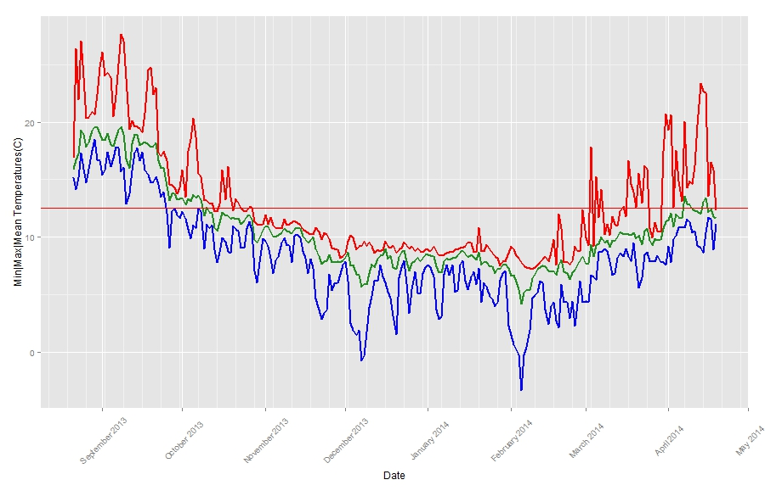
Figure 4. Dabob Temperature Data in Celsius (August 2013 to April 2014) Blue line is minimum daily temperature, red line is maximum daily temperature, light blue line is median daily temperature, red horizontal line is 12.5C spawning threshold.

Month | Mean Temperature | Std. Dev. | Maximum (Obs) | Minimum (Obs)
2013-08 | 18.49337 | +/-2.037215 | 27.075 | 14.134
2013-09 | 17.12595 | +/-2.475945 | 27.665 | 9.077
2013-10 | 11.86964 | +/-1.487143 | 20.329 | 6.064
2013-11 | 9.489874 | +/-1.581117 | 11.916 | 2.837
2013-12 | 7.710751 | +/-1.680059 | 10.161 | -0.774
2014-01 | 7.901633 | +/-1.032483 | 10.846 | 2.303
2014-02 | 6.753191 | +/-1.877149 | 12.401 | -3.316
2014-03 | 9.752109 | +/-1.616441 | 20.71 | 4.311
2014-04 | 12.24793 | +/-2.201719 | 23.388 | 7.782
Table 4. Monthly Temperature Statistics for Dabob.

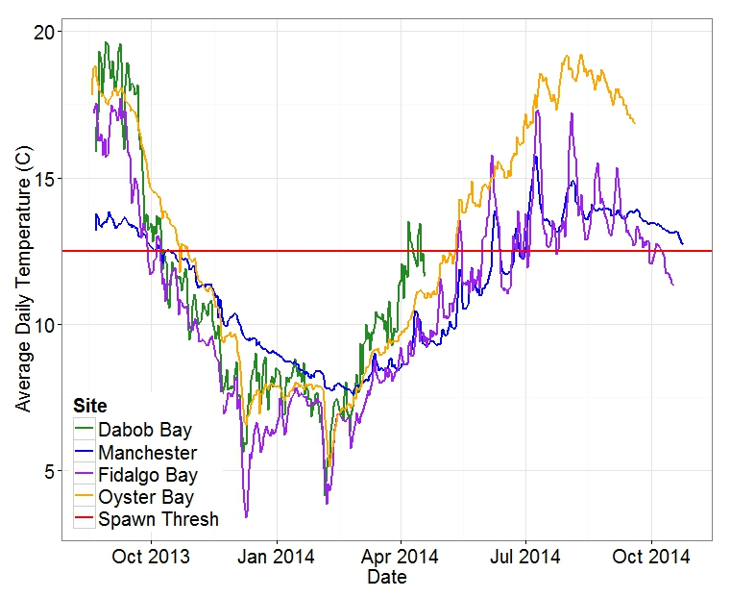
Figure 1. Average Daily Temperatures for all 4 sites. Dabob = Green, Manchester = Blue, Fidalgo Bay = Purple, Oyster Bay = Orange, 12.5 C Spawn Threshold = Red

Site/Threshold | >= 20 C | <= 5 C
Manchester | 0 | 0
Dabob | 33 | 52
Fidalgo | 4 | 20
Oyster Bay | 34 | 5
Table 1. Number of Days experiencing maximum or minimum at or beyond temperature extremes.
--

Group | Fidalgo Bay | Manchester | Oyster Bay | Dabob*
Fidalgo | 29.1+/-5.14 | 24.4+/-5.77 | 34.7+/-6.53 | 14.4
Dabob | 24.4+/-4.48 | 21.5+/-4.96 | 28.0+/-5.60 | 13.4
Oyster Bay | 28.9+/-5.14 | 24.0+/-4.98 | 28.0+/-5.2 | 13.4
Table xx. Average Size for each group at each site after 8 (Dabob Bay), 13 (Oyster Bay), or 14 (Fidalgo/Manchester) months post outplant. Sizes in mm.

Group/Site | Fidalgo Bay | Manchester | Oyster Bay
Fidalgo | 29.9+/-4.97 | 25.5+/-3.87 | 29.9+/-3.96
Dabob | 22.9+/-4.29 | 19.1+/-3.72 | 26.2+/-2.80
Oyster Bay | 28.9+/-3.60 | 22.4+/-3.12 | 27.5+/-3.61
Table xx. Average Size at Brooding per group per site. Sizes in mm.

Site/Pop | 1N | 1H | 1S | 2N | 2H | 2S | 4N | 4H | 4S
1N | -------------- | 0.0051464 | 0.0606544 | 1.0000000 | 0.0000767 | 0.9666700 | 0.3534660 | 0.0000000 | 0.0000001
1H | 0.0051464 | -------------- | 0.8283448 | 0.2364509 | 0.3744056 | 0.0801646 | 0.9999927 | 0.0000377 | 0.0583953
1S | 0.0606544 | 0.8283448 | -------------- | 0.7124328 | 0.0227243 | 0.5711141 | 0.9784194 | 0.0000000 | 0.0002118
2N | 1.0000000 | 0.2364509 | 0.7124328 | -------------- | 0.0049557 | 0.9990434 | 0.5702244 | 0.0000002 | 0.0002760
2H | 0.0000767 | 0.3744056 | 0.0227243 | 0.0049557 | -------------- | 0.0009451 | 0.9601763 | 0.4564115 | 0.9999980
2S | 0.9666700 | 0.0801646 | 0.5711141 | 0.9990434 | 0.0009451 | -------------- | 0.6871788 | 0.0000000 | 0.0000024
4N | 0.3534660 | 0.9999927 | 0.9784194 | 0.5702244 | 0.9601763 | 0.6871788 | -------------- | 0.0895671 | 0.8554460
4H | 0.0000000 | 0.0000377 | 0.0000000 | 0.0000002 | 0.4564115 | 0.0000000 | 0.0895671 | -------------- | 0.4931960
4S | 0.0000001 | 0.0583953 | 0.0002118 | 0.0002760 | 0.9999980 | 0.0000024 | 0.8554460 | 0.4931960 | --------------
Table xx. Associated P-Value for Size per Population by Site. Numbers are sites (1 = Oyster Bay, 2 = Fidalgo Bay, 4 = Clam Bay). Letters are populations (N = Fidalgo Bay, H = Dabob Bay, S = Oyster Bay).

Group/Site | Fidalgo Bay | Manchester | Oyster Bay
Fidalgo | 19 | 22 | 20
Dabob | 19 | 15 | 19
Oyster Bay | 21 | 16 | 19
Table xx. Minimum Observed Size at Brooding per group per site. Sizes in mm.

 | 12.5 C Threshold | Oyster Bay Peak Brooding | Dabob  Peak Brooding | Fidalgo  Peak Brooding
Oyster Bay | 133 DD | 307.894 DD | 453.021 DD | 453.021 DD
Manchester | 113 DD | 377.561 DD | 377.561 DD | 175.322 DD
Fidalgo Bay | 143 DD | 354.156 DD | 512.99 DD | 512.999 DD
Table 3. Degree Days from 8C minimum at each Site for each population as well as 12.5 C spawning threshold.

